**Discussion 5: Concurrency**

**Concurrency**

1. CS10 has decided to open a pizzeria! To make a pizza, the following tasks must completed:  

|  |  |
| --- | --- |
| **Task** | **Time** |
| Make the dough | 25 minutes |
| Make the sauce | 25 minutes |
| Prepare the toppings | 10 minutes |
| Assemble the pizza | 10 minutes |
| Bake the pizza | 50 minutes |

a. Which of these tasks must be completed in serial?

**Answer** : assemble pizza and bake the pizza is take place in series

 b. Which of these tasks can be completed in parallel?

**Answer**: make the dough, make the sauce, and prepare toppings is take place in parallel

c. How fast can we make a single pizza?

**Answer**: minimum time require to this is 60 minutes

d. How many employees would the pizzeria need to make a pizza this fast?

**Answer**: there are minimum four employees would the pizzeria need to make a pizza this fast.

2. Assume we click the green flag to run the code below, then wait 60 seconds. What are all the possible values of magic after 60 seconds have elapsed?

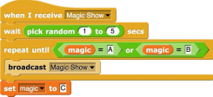

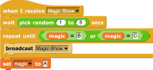

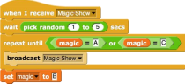

Possible values of magic :The code gets caught in a deadlock

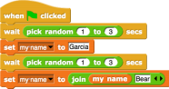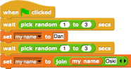3. Which of the following could be the value of my _ name after the green flag is clicked?

Dan

Garcia

Dan Bear

Garcia Oski

**Dan BearOski**

Garcia Dan

Oski

**Dan OskiBear**

Challenge

1. List all possible values of grade after the green flag is clicked.

https://lh6.googleusercontent.com/H8v9Gh3lzaVuolBuDrw2cisj_201KkE0gJsZNKIwcIykVe6ly-u3xHmjPjT059TXOXdwPTPzrMAtd1M3cOlbaTwdy2B-5cVxpZd6cXgUZ9tHntKCN-WKER1HSf2xZn1bk0BVxAzfhttps://lh6.googleusercontent.com/Wk2GtrmGgTW6NymgyQhZdWNCj5MOzCfswVRvarU12pnKGtg9d9z6Zj9Nrmme1rwSgoYp2-Nv5LKCM_oAi6WI4_bEroGBYBuHRXrO0mGohgijGE1Af_hNTbHsA0HAVzkp_Q4HjjXT

Here are the definitions of the blocks used in the above scripts:

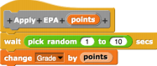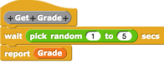

Possible values of grade**: 225 , 150 , 105 , 195**